8086 Flag Register
Dept. of Computer Science and Engineering

Lecture References:
□ Book:
□ Microprocessors and Interfacing: Programming and Hardware, Chapter # 2, Author: Douglas V. Hall

8086 Flag Register
- 16-Bit register
  - 7 bits are undefined/unused (marked by red x in the figure below)
  - 6 status/condition flags (marked by blue circles)
  - 3 control flags (those in grey boxes)
- The condition flags are set (1) or reset (0) depending on the result of an arithmetic/logical operation.
- Control flags control the operations of the CPU

Bit Positions
15 14 13 12 11 10 9 8 7 6 5 4 3 2 1 0

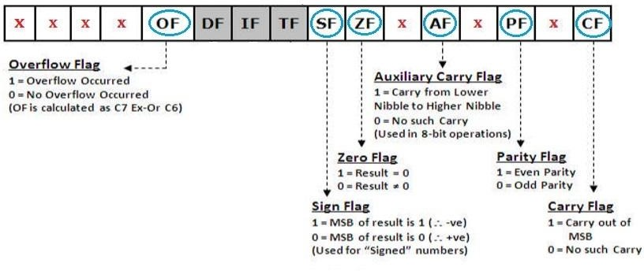
Status Flags

Flags are useful in programming e.g. when writing conditions such as:
- If answer is zero, do … else …. // zero flag comes in hand here
- If answer is less than zero, do … else …. // sign flag can be

4 used here

Status Flags
- Carry Flag (CF) - is set to ’1’ when there is an unsigned overflow. E.g. when you add bytes 255 + 1 (result is not in range
0...255). When there is no overflow this flag is reset to 0.
- Parity Flag (PF) - set to ’1’ when there is even number of one bits in result, and reset to ’0’ when there is odd number of one bits. Even if result is a word only lower 8 bits are analyzed!
- Auxiliary Flag (AF) - set to ’1’ when there is an unsigned overflow for low nibble (4 bits).

Status Flags
- Zero Flag (ZF) - set to ’1’ when result is zero. For non-zero result this flag is reset to ’0’.
- Sign Flag (SF) - set to ’1’ when result is negative. When result is positive it is reset to ‘0’. (This flag takes the value of the most
significant bit).
- Overflow Flag (OF) - set to ’1’ when there is a signed overflow. For example, when you add bytes 100 + 50.







Status Flags
NB:
OF is set to 1 if there is a carry from:
- the 7th bit to the 8th bit ONLY or
- from the 8th bit to the 9th bit ONLY
If there is a carry from the 7th bit to the 8th bit and from the 8th bit to the 9th bit at THE SAME TIME then OF = 0

OF=1
Set because there is a carry from the 7th bit to the 8th bit ONLY
Carry 1 1 1
AF=0
Reset because there is NO carry from the lower nibble to the upper nibble

  - MOV AL, 50h ( 0 1 0 1 0 0 0 0 )
  - MOV BL, 32h ( 0 0 1 1 0 0 1 0 )

- ADD AL, BL
(x 1 0 0 0 0 0 1 0 )
CF=0 ZF=0
Reset because the answer has NO carry
SF=1
Set because the MSB is 1 indicating a negative answer
Reset because the answer is NOT zero
PF=1
Set because the answer has an EVEN number of 1s

Status Flags
NB:
OF is reset to 0 if:
- there is a carry from the the 7th bit to the 8th bit and from the
8th bit to the 9th bit at THE SAME TIME or
- there is NO carry from the the 7th bit to the 8th bit and from the 8th bit to the 9th bit at THE SAME TIME

OF=0
Reset because there is a carry from the 7th bit to the 8th bit and from the 8th bit to the 9th bit at THE SAME TIME
Carry 1 1 1 1 1 1 1 1

AF=1
Set because there IS a carry from

- MOV | AL, | FFh | 1 | 1 | 1 | 1 | 1 | 1 | 1 | 1 | the lower nibble to the upper nibble
- MOV | BL, | 01h | 0 | 0 | 0 | 0 | 0 | 0 | 0 | 1

  - ADD AL, BL

CF=1
Set because the answer has a
1 0 0 0 0 0 0 0 0

ZF=1
Set because the answer IS zero
PF=1






carry SF=0
Reset because the MSB is 0 indicating a positive answer
Set because the answer has an EVEN number of 1s

Control Flags:

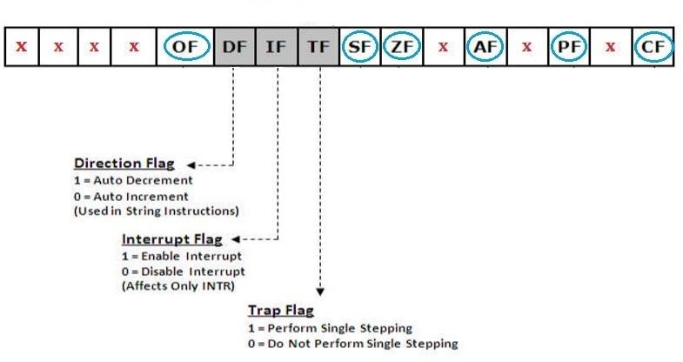

Control Flags:
  - Trap Flag (TF) - Used for on-chip single-step debugging.
  - Interrupt enable Flag (IF) - when this flag is set to ’1’ CPU reacts to interrupts from external devices.
  - Direction Flag (DF) - this flag is used by some instructions to process data chains, when this flag is set to ’0’ - the processing is done forward, when this flag is
set to ‘1’ the processing is done backward.

Quiz: Status Flag Values?

- MOV | AX, | ABCDh
- MOV | BX, | 9876h
- ADD | AX, | BX


Thank You !!

